1. **Failure Detection and Handling (Exception handling) in Ariane 5 explosion:**

The explosion resulted due to an error in the software system. The Arianne 5 explosion is one of the example for how a mission critical system is seriously affected due to a software system. This error is due to some numerical conversion. The velocity of the rocket which serves as an important factor which should be a 64 bit floating point was replaced by the 16 bit signed integer in the conversion process. Sue to this conversion there occurred an overflow in the system which wasn’t handled by any exception handling. Due to this error the hardware system was faced with an exception and which in turn led to the crashing and explosion.

The below is for detecting fault in the critical level of the system:

//Normal execution of the program

while(rocketStatus==True):

//do stats checking

If(convertVelocity()):

Try:

convertVelocity(vel) // if convertion does not cause any overflow

catch:

conversionException() // if there is any error due to conversion call the method

The above code is for any fault detection in the system.

The below is for handling fault in the critical level of the system:

def conversionException(): // Incase of an error during conversion

notify_Contol_Center(err)

notify_Ground_Staff(err)

maintain_AutoPilot(course)

2. **Test cases that should have been there to verify the software**

1. To ensure the communication between the systems are stable and not with issues and errors.

Input: A set of data transmission between systems to ensure the communication is right

Execution:

• Provide a range of valid inputs to the system

• Process the input in each system and the transmit the resultant value

• check whether the data sent and received are same on both the ends.

• Also check whether the results are acknowledged by each system.

Output: If the data is transmitted properly then the proper transmission between the systems is established

1. Since the conversion of numerical value from 64 bit float to the 16 bit integer caused the major issue, we need to check its validity

Input: An input value to determine the desired output

Execution:

• set a function that checks whether it’s the right data that is being transmitted

• Provide the function with a set of inputs with constraints and possible ranged which makes sure that the function is stable throughout the process and it is not deviating from the result values for each input.

• If an exception occurs then the system should have a failsafe to provide exit strategy.

Output: Data received after the process of input is the desired and it stays consistent throughout the process.

1. **State Transition Diagram to show the Explosion occurrence in Arianne 5:**

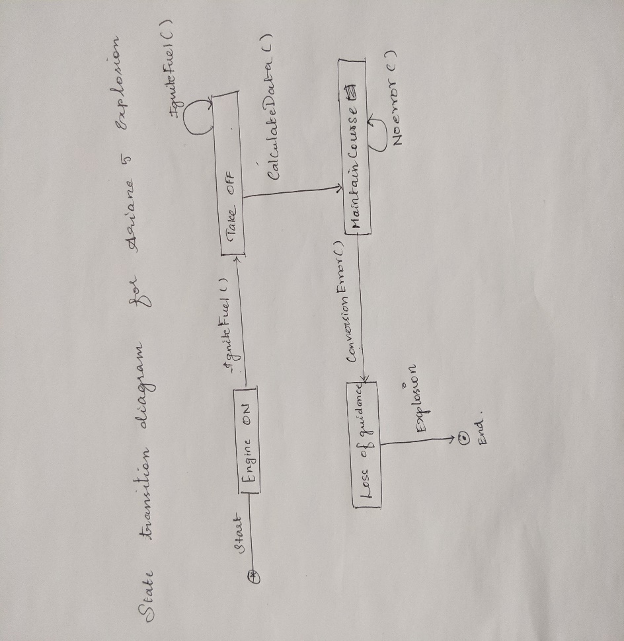

1. **Risk Exposure assessment for this mission critical system automation:**

Exposure assessment is the process of measuring the duration of exposure of a substance or people to an agent. This considers the amount and the characteristics of the substance which is being exposed. Usually, it describes the sources and the uncertainties in the assessment.

**Risk exposure = Probability of risk to occur * total loss due to the risk occurred**

In this case the probability is 1 because the risk occurred and it lead to the loss

The loss is calculated in terms of cash. As per the SpaceNews report the amount it cost was roughly 137 million.

Hence

**Risk exposure = 1 * 137 million**